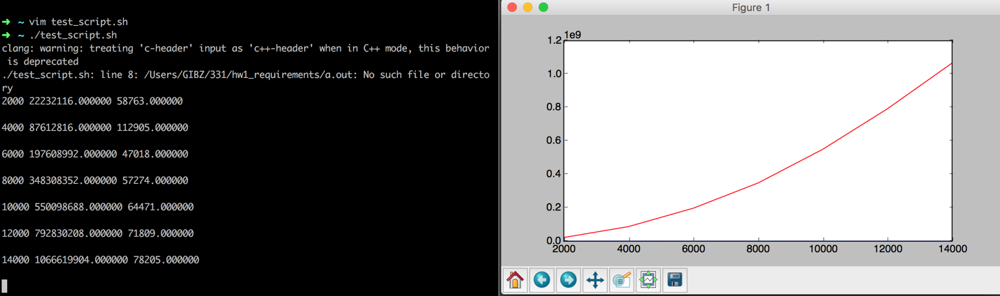

Red: Quadratic Nature- bubblesort

Blue: Can’t see very well because of mismatch of units (nano/milli), temp array method

I wrote a python program to generate files of a specified number of random integers in between 1 and 20,000, namely N=2000:14000 (in increments of 2000). Files in the format N_(Nvalue).txt

With these files at hand, I modified main.cpp so that it read each of these .txt files above. With each, it processes the file putting each random integer into a vector. Then both methods were used to find the k’th largest value and timed. This value of N, and the two times are written to a .txt file space delimited in the format

{N} {bubblesort_time} {temparray_time}

I then wrote a python program to parse this file of 6 lines, 18 elements. It stores all of the values of N in a list, and each of the method’s results in a list of their own. Then it uses a MATLAB module “matplotlib” in order to plot both of these on the same axes.

Questions or concerns,

Jordan Giebas

[giebasjo@msu.edu](mailto:giebasjo@msu.edu)